* **Documentation !**

1. **Website Name: *Khaadi* & *Bonanza* *Satrangi*.**
2. **Group Name: “L.L “**
3. **Team member Name:**

* ***Laiba* *Nadeem***
* ***Labiqa* *Shahid*.**

1. **Student ID:**

* ***Laibqa* *80933***
* ***Laiba* *80982***

1. **Campus Name: *Homeopathic* *Medical* *College* *For* *Boys*,*Board* *Office*.**
2. **Batch code: *1605***
3. **Teacher Name: *Sumbul* M.*Saleem.***
4. **Total page’s: 5 *page’s***

* **Landing Page**
* **Home**
* **About**
* **Collection**
* **Contact**
* **Presentation !**

**This is me Laibqa and this is Laiba .We created a website on Khaadi**

**and Bonanza Satrangi Brand . If you go to the website,you will sea the**

**logo of the this brand . Then you will go to about page,then we have**

**given it’s full details in which everything has been told from its history**

**and order it’s cancellation . Then we will go to the collection,there is**

**a collection of these brands, which includes the price of the clothes,**

**the quality of the clothes,etc.Then we will go to the contact page,then**

**the numbers and email f there brands are included, besides it is also**

**known that you can visit and shop they and their live location is also**

**included!**

* **Reviews !....**

Al-Khidmat understand the rights of every child of

Fair and bright future and is here to make “Dream

Into reality “. Bano Qabil a stairway towards a bright

Future is a career growth initiative for students from

All over Karachi and Hyderabad…

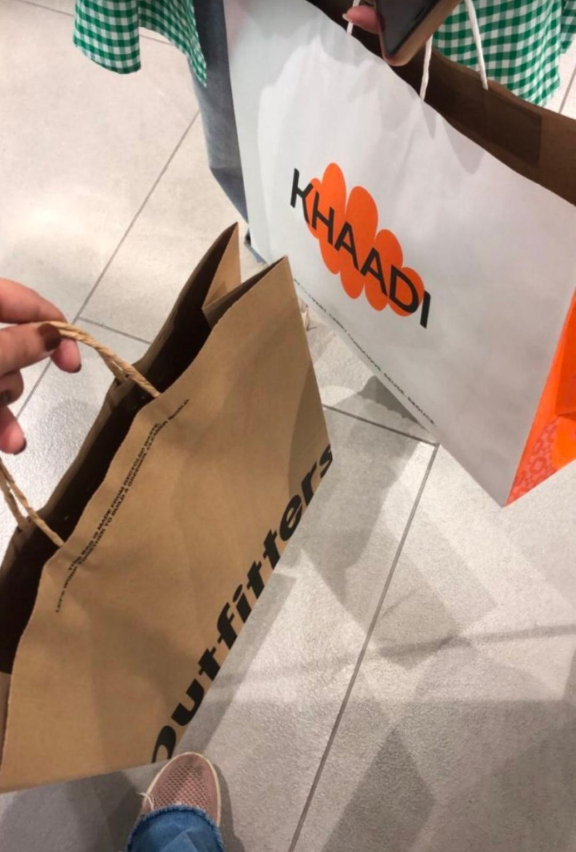**Teacher Name: *Sumbul* M.*Saleem*.**